
昆士兰银行主营个人及商业存贷及保险业务
Bank of Queensland Limited (BOQ) is an Australia-based entity engaged in retail banking, leasing finance and insurance products. The Bank operates in two segments which are Retail banking and Business Banking.
相关板块：金融板块，标普澳洲300
Related Sectors:
Financials
S&P/ASX 300

资产负债表（带A为实际，带E为估计）
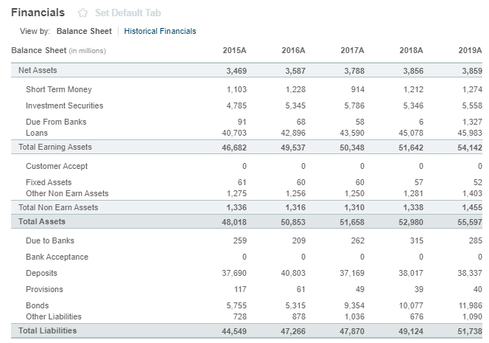

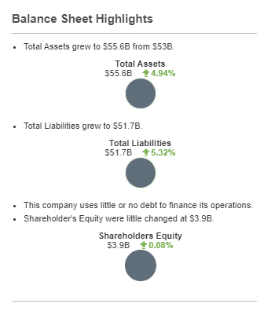

注册地址，官网及联系方式
Level 6, 100 Skyring Tce
Newstead, QLD 4006
Not Available
www.boq.com.au
Tel: +61 7 3212 3333
Fax: +61 7 3212 3409
Investor relations phone:
+61 7 3212 3990

