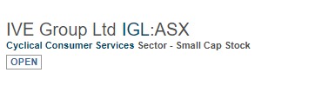
IVE集团主营创意传媒，移动传媒和互动传媒
IVE Group Limited (IGL) is into Conceptual and creative design across print, mobile and interactive media; Printing of catalogues, magazines, marketing and corporate communications materials and stationery; Manufacturing of point of sale display material and large format banners for retail applications; Personalised communications including marketing automation, ma...More
相关板块：产业板块，标普澳洲300
Related Sectors:
Consumer Cyclicals
S&P/ASX 300

资产负债表（带A为实际，带E为估计）
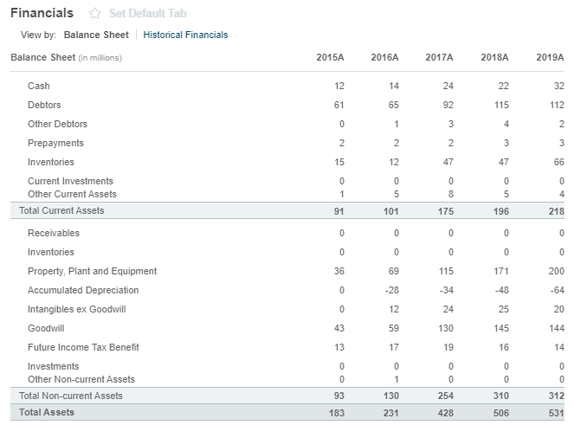
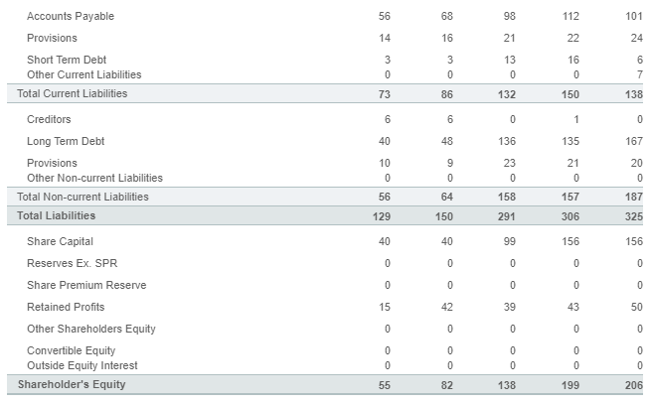

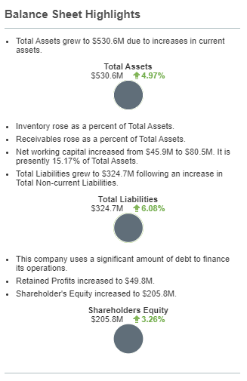

注册地址，官网及联系方式
IVE Group Ltd
Level 3, 35 Clarence St
Sydney, NSW 2000
Not Available
www.ivegroup.com.au
Tel: +61 2 9089 8550
Fax: Not Available
Investor relations phone:
+61 4 5508 8099

