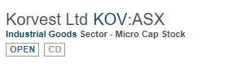
可泳斯主营金属片加工，电泳，电缆加工及移动设备设计和制造
Korvest Ltd (KOV) is a South Australia based manufacturing company with principal activities comprising of hot dip galvanising, sheet metal fabrication, manufacture of cable and pipe support systems and fittings, design and assembly of access systems for large mobile equipment and sale, repair and rental of high torque tools. The Company has two segments: Industria...More
相关板块：产业板块，标普澳洲300
Related Sectors:
Industrials
S&P/ASX 300

资产负债表（带A为实际，带E为估计）
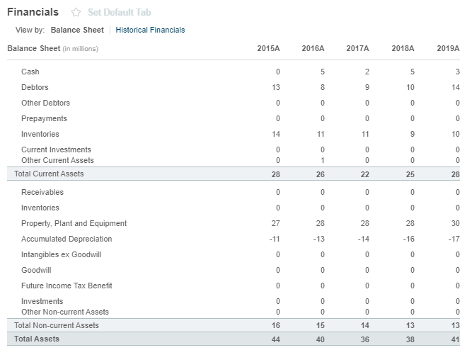
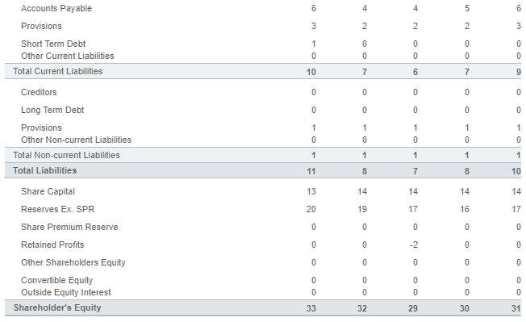

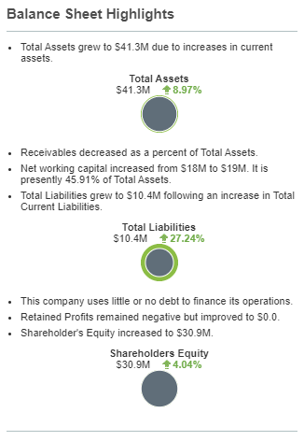

注册地址，官网及联系方式
Korvest Ltd
580 Prospect Rd
Kilburn, SA 5084
Not Available
www.korvest.com.au
Tel: +61 8 8360 4500
Fax: +61 8 8360 4599
Investor relations phone:
Not Available

