
Company Summary
McMillan Shakespeare Limited (MMS) provides services of salary packaging, novated leasing and fleet & asset management. Through its brands Maxxia, RemServ, Interleasing and Holden Leasing, MMS provides services to major employers across Australia, New Zealand and the United Kingdom. Its client includes Federal and State Governments, hospitals, not-for-profit organi...More
Related Sectors:
- Financials
- S&P/ASX 300

资产负债表（带A为实际，带E为估计）
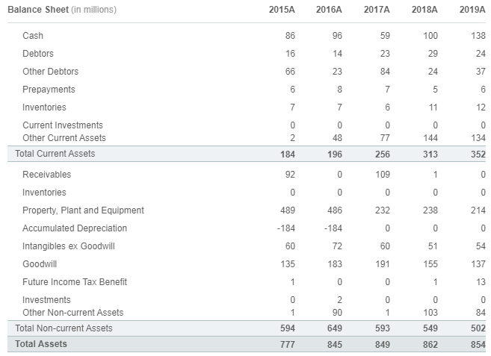

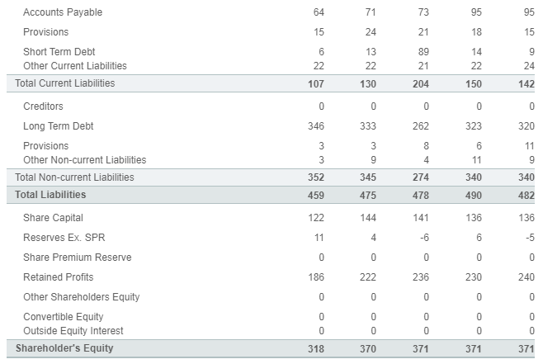
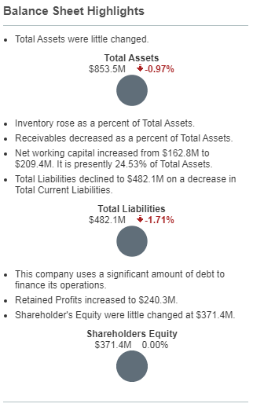
注册地址，官网及联系方式
Contact MMS

Mcmillan Shakespeare Ltd
Level 21, 360 Elizabeth St
Melbourne, VIC 3000
Not Available
www.mmsg.com.au
- Tel: +61 3 9097 3273
- Fax: +61 3 9097 3060
Investor relations phone:
Not Available

