
国民银行主营各类银行，金融，财富管理业务遍及澳纽，亚洲及英美
National Australia Bank Limited (NAB) is a financial services group that provides a comprehensive and integrated range of banking and financial services including wealth management throughout Australia and New Zealand, with branches located in Asia, the United Kingdom (UK) and the United States (US).
相关板块：金融板块，标普澳洲300
Related Sectors:
Financials
S&P/ASX 300

资产负债表（带A为实际，带E为估计）
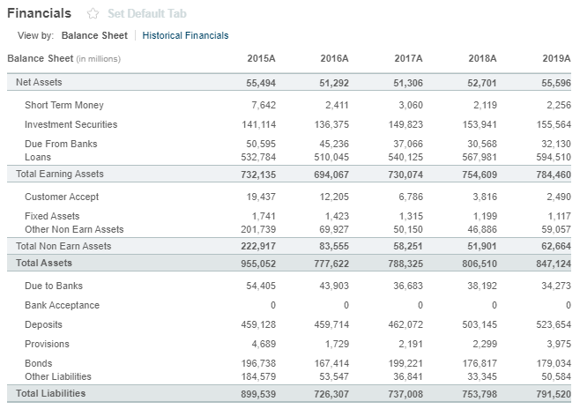

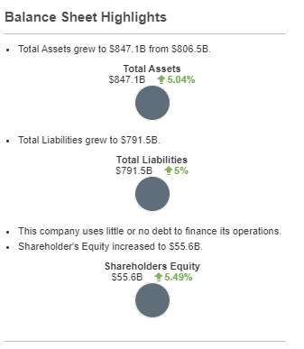

注册地址，官网及联系方式
National Australia Bank Ltd
800 Bourke St
Docklands, VIC 3008
Not Available
www.nab.com.au
Tel: +61 3 8634 8235
Fax: +61 3 8872 2461
Investor relations phone:
+61 4 7730 2010

