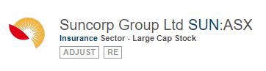
申确集团主营澳纽120家男女须刨零售店
Suncorp Group Limited (SUN) is a Queensland-based financial services conglomerate offering retail and business banking, general insurance, life insurance, superannuation and investment products in Australia and New Zealand. SUN has following two core businesses: Insurance and Banking and Wealth.
相关板块：金融板块，标普澳洲300
Related Sectors:
Financials
S&P/ASX 300

资产负债表（带A为实际，带E为估计）
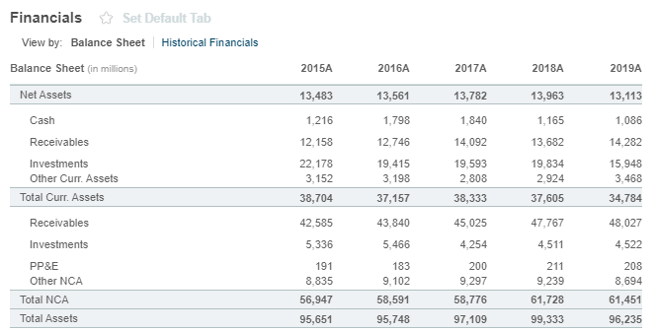
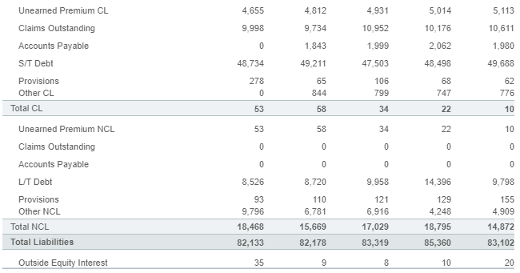
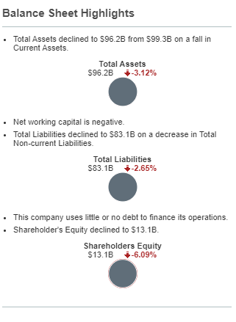

注册地址，官网及联系方式
Suncorp Group Ltd
Level 28, Brisbane Square, 266 George St
Brisbane, QLD 4000
Not Available
www.suncorpgroup.com.au
Tel: +61 7 3362 1222
Fax: +61 7 3135 2940
Investor relations phone:
+61 4 1460 9192

